

2019 First Semester Graduate Studies
Academic Information for
Master and Doctoral Degree
Program Students

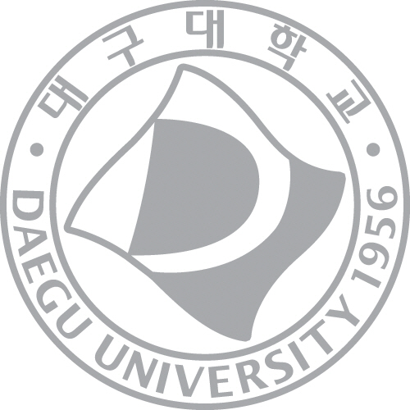

대 구 대 학 교 대 학 원
DAEGU UNIVERSITY GRADUATE SCHOOL

Contents

Daegu University Graduate School's Mission Statement Chart 3
Daegu University Graduate School's Development Strategies and Vision 4
2019 Academic Calendar 5
Required Documents for New Students 8
Lecture Registration Information 9
Graduate School Web Site 13
Graduate School Academic Information 14
Student ID Cards 19
Guidelines for Dissertation Thesis Submission 20
Graduate School Scholarships 23
Access to Library 26
Additional Information 30
*Credit Transfer Application for Supplementary Unit Credits 32

Daegu University Graduate School's Mission Statement Chart

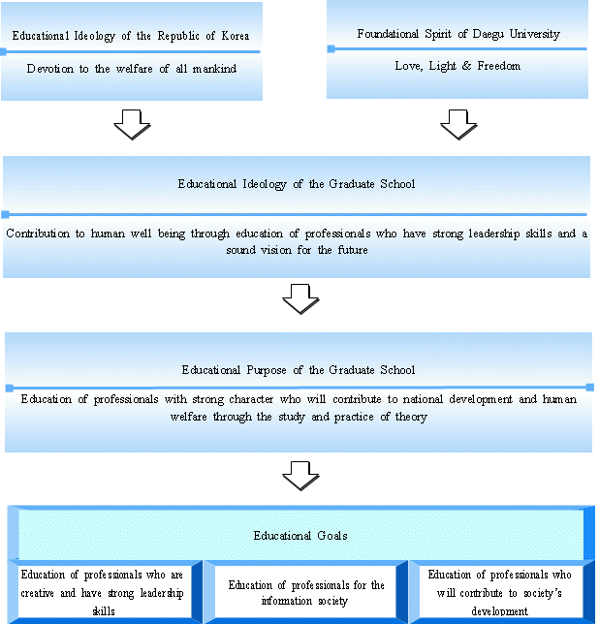

Daegu University Graduate School's
Development Strategies and Vision


● A New leader in the 21st century
● A young graduate school at the forefront of creative change
● A grand graduate school that embodies the welfare of all people
● An open-minded Graduate School, working together with the local community
Development Goals
● Long-term: To emerge as Korea's number-one comprehensive welfare graduate school
● Medium-term: To establish the top graduate school in the Daegu and Gyeongbuk area
● Short-term: To create a self-supporting foundation based on specialization policies
Specialization Goals

Development Strategies
Management Goals
● To substantialize education and strengthen research through innovative curriculum reform
● Management and administrative reform to establish substantial specialization
● To establish 24 hour research environment and the policy of educating a select few
● To be a national leader in specialization in early stage and maintain the status
● To establish the foundation of continuous specialization and maximize the capacity
Specialization Fields Ⅰ
● Special Education
● Rehabilitation Science
● Social Welfare
Specialization Fields Ⅱ
●Information &
Communication Engineering
● Bio Industry
● Design

● To foster active and consumer-oriented
academic management
● To establish professional
and effective administration
systems
● To secure reliable financial
competition and fiscal
responsibility



2019 Academic Calendar

First Semester
Year |  | Sun | Mon | Tue | Wed | Thu | Fri | Sat | Date | Schedule
2019 | 2 |  |  |  |  |  | 1 | 2 | 1(Fri)- 28(Thu)  4(Mon)- 6(Wed)  18(Mon)-21(Thu)  20(Wed)-26(Tue)  22(Fri)  27(Wed)-28(Thu)  25(Mon)- 3.8(Fri) | ▪Application period for General leave of absence and Return from absence  ▪ Lunar New Year’s Holidays  ▪1st Semester - Lecture registration period  ▪1st Semester – enrollment period  ▪Graduation ceremony  ▪Class registration for new students  ▪Application period for research registration
2019 | 2 | 3 | 4 | 5 | 6 | 7 | 8 | 9
2019 | 2 | 10 | 11 | 12 | 13 | 14 | 15 | 16
2019 | 2 | 17 | 18 | 19 | 20 | 21 | 22 | 23
2019 | 2 | 24 | 25 | 26 | 27 | 28
2019 | 3 |  |  |  |  |  | 1 | 2 | 1(Fri)  4(Mon)  6(Wed)-8(Fri)  11(Mon)-15(Fri)  25(Mon)-4. 5(Fri) | ▪ Korean March 1st Movement day  ▪ Classes begin  ▪ Class change & withdrawal  ▪Application for Foreign language examination and Comprehensive examination  ▪ Foreign language and comprehensive exam
2019 | 3 | 3 | 4 | 5 | 6 | 7 | 8 | 9
2019 | 3 | 10 | 11 | 12 | 13 | 14 | 15 | 16
2019 | 3 | 17 | 18 | 19 | 20 | 21 | 22 | 23
2019 | 3 | 24  31 | 25 | 26 | 27 | 28 | 19 | 30
2019 | 4 |  | 1 | 2 | 3 | 4 | 5 | 6 | 7(Sun)  8(Mon)-12(Fri)  22(Mon)-26(Fri)  25(Thu)  22(Mon)-26(Fri)  22(Mon)-26(Fri) | ▪One-third point of the 1st Semester’s coursework  ▪Submission of Foreign Language and Comprehensive examination result  ▪ Mid-term examination period  ▪ Half-way point of the 1st Semester’s coursework  ▪Submission of the nomination form of thesis examiners  ▪Submission of the application for thesis presentation and examination
2019 | 4 | 7 | 8 | 9 | 10 | 11 | 12 | 13
2019 | 4 | 14 | 15 | 16 | 17 | 18 | 19 | 20
2019 | 4 | 21 | 22 | 23 | 24 | 25 | 26 | 27
2019 | 4 | 28 | 29 | 30
2019 | 5 |  |  |  | 1 | 2 | 3 | 4 | 1(Wed)  6(Mon)  14(Tue)  20(Mon)-31(Fri) | ▪University Foundation day (Supplementary class: JUNE 12th)  ▪Temporary holiday (Supplementary class: JUNE 10th)  ▪Two-thirds point of the 1st Semester’s coursework  ▪Submission of the results of public oral presentation of thesis
2019 | 5 | 5 | 6 | 7 | 8 | 9 | 10 | 11 | 1(Wed)  6(Mon)  14(Tue)  20(Mon)-31(Fri)
2019 | 5 | 12 | 13 | 14 | 15 | 16 | 17 | 18 | 1(Wed)  6(Mon)  14(Tue)  20(Mon)-31(Fri)
2019 | 5 | 19 | 20 | 21 | 22 | 23 | 24 | 25 | 1(Wed)  6(Mon)  14(Tue)  20(Mon)-31(Fri)
2019 | 5 | 26 | 27 | 28 | 29 | 30 | 31 |  | 1(Wed)  6(Mon)  14(Tue)  20(Mon)-31(Fri)
2019 | 6 |  |  |  |  |  |  | 1 | 6(Thu)  10(Mon)-12(Wed)  13(Thu)-19(Wed)  17(Mon)-28(Fri)  17(Mon)-28(Fri)  17(Mon)-28(Fri)  20(Thu) | ▪ Memorial Day (Supplementary class: JUNE 11^{st)}  ▪ Period for Supplementary Classes  ▪ Final examination  ▪Submission of thesis supervising professor nomination form  ▪Submission of the report of thesis proposal  ▪Submission of the final report of dissertation examination  ▪ Summer vacation begins
2019 | 6 | 2 | 3 | 4 | 5 | 6 | 7 | 8
2019 | 6 | 9 | 10 | 11 | 12 | 13 | 14 | 15
2019 | 6 | 16 | 17 | 18 | 19 | 20 | 21 | 22
2019 | 6 | 23  31 | 24 | 25 | 26 | 27 | 28 | 29
2019 | 7 |  | 1 | 2 | 3 | 4 | 5 | 6 | 1(Mon) - 12(Fri) | ▪Application period for thesis submission and submission of completed thesis hardcopy
2019 | 7 | 7 | 8 | 9 | 10 | 11 | 12 | 13 | 1(Mon) - 12(Fri)
2019 | 7 | 14 | 15 | 16 | 17 | 18 | 19 | 20 | 1(Mon) - 12(Fri)
2019 | 7 | 21 | 22 | 23 | 24 | 25 | 26 | 27 | 1(Mon) - 12(Fri)
2019 | 7 | 28 | 29 | 30 | 31 |  |  |  | 1(Mon) - 12(Fri)
2019 | 8 |  |  |  |  | 1 | 2 | 3 | 1(Thu) -30(Fri)  15(Thu)  19(Mon)-22(Thu)  23(Fri)  26(Mon)-29(Thu)  26(Mon)-9.6(Fri)  29(Thu)-30(Fri) | ▪Application period for General leave of absence and Return from absence  ▪Korea liberation day  ▪2ndSemester - Lecture registration period  ▪Graduation ceremony  ▪2nd Semester - Enrollment period  ▪Application period for research registration  ▪Class registration for new students
2019 | 8 | 4 | 5 | 6 | 7 | 8 | 9 | 10
2019 | 8 | 11 | 12 | 13 | 14 | 15 | 16 | 17
2019 | 8 | 18 | 19 | 20 | 21 | 22 | 23 | 24
2019 | 8 | 25 | 26 | 27 | 28 | 29 | 30 | 31

Second Semester
Year |  | Sun | Mon | Tue | Wed | Thu | Fri | Sat | Date | Schedule
 | 9 | 1 | 2 | 3 | 4 | 5 | 6 | 7 | 2(Mon)  4(Wed) - 6(Fri)  8.26(Mon)-6(Fri)  12 (Thu) -14(Sat)  9(Mon) -17(Tue)  25(Wed)-10.11(Fri) | ▪Classes begin  ▪Class change & withdrawal  ▪Application period for research registration  ▪Chuseok Holiday (Supplementary class: DEC. 9th, 10th)  ▪Application for Foreign language examination and Comprehensive examination  ▪Foreign language and comprehensive exam
 | 9 | 8 | 9 | 10 | 11 | 12 | 13 | 14
 | 9 | 15 | 16 | 17 | 18 | 19 | 20 | 21
 | 9 | 22 | 23 | 24 | 25 | 26 | 27 | 28
 | 9 | 29 | 30
 | 10 |  |  | 1 | 2 | 3 | 4 | 5 | 3(Thu)  9(Wed)  10(Thu)  14(Mon) -18(Fri)  21(Mon) -25(Fri)  21(Mon) -25(Fri)  21(Mon) -25(Fri  28(Mon) | ▪National Foundation day (Supplementary Class: DEC. 12th)  ▪Hanguel Day (Supplementary Class: DEC. 11st)  ▪One-third point of the 2nd Semester’s coursework  ▪Submission of Foreign Language and Comprehensive examination result  ▪Submission of the nomination form of thesis examiners  ▪Submission of the application for thesis presentation and examination  ▪Mid-term examination period  ▪Half-way point of the 2nd Semester’s coursework
 | 10 | 6 | 7 | 8 | 9 | 10 | 11 | 12
 | 10 | 13 | 14 | 15 | 16 | 17 | 18 | 19
 | 10 | 20  27 | 21  28 | 22  29 | 23  30 | 24  31 | 25 | 26
 | 11 |  |  |  |  |  | 1 | 2 | 18(Mon) -29(Fri)  14(Thu) | ▪ Submission of the results of public oral presentation of thesis  ▪Two-thirds point of the 2nd Semester’s coursework
 | 11 | 3 | 4 | 5 | 6 | 7 | 8 | 9 | 18(Mon) -29(Fri)  14(Thu)
 | 11 | 10 | 11 | 12 | 13 | 14 | 15 | 16 | 18(Mon) -29(Fri)  14(Thu)
 | 11 | 17 | 18 | 19 | 20 | 21 | 22 | 23 | 18(Mon) -29(Fri)  14(Thu)
 | 11 | 24 | 25 | 26 | 27 | 28 | 29 | 30 | 18(Mon) -29(Fri)  14(Thu)
 | 12 |  |  |  |  |  |  |  | 9(Mon)-12(Thu)  13(Fri)-19(Thu)  16(Mon)-27(Fri)  16(Mon)-27(Fri)  16(Mon)-27(Fri)  20(Fri)  25(Wed) | ▪Period for Supplementary Classes  ▪Final examination  ▪Submission of thesis supervising professor nomination form  ▪Submission of the report of thesis proposal  ▪Submission of the final report of dissertation examination  ▪Winter vacation begins  ▪Christmas
 | 12 | 1 | 2 | 3 | 4 | 5 | 6 | 7
 | 12 | 8 | 9 | 10 | 11 | 12 | 12 | 14
 | 12 | 15 | 16 | 17 | 18 | 19 | 20 | 21
 | 12 | 22 | 23 | 24 | 25 | 26 | 27 | 28
 | 12 | 29 | 30 | 31
2020 | 1 |  |  |  | 1 | 2 | 3 | 4 | 1(Wed)  2(Thu) - 10(Fri)  24(Fri)-26(Sun)  27(Mon) | ▪ New Year’s Day  ▪Application period for thesis submission and submission of completed thesis hardcopy  ▪Lunar New Year’s Holidays  ▪Temporary holiday
2020 | 1 | 5 | 6 | 7 | 8 | 9 | 10 | 11 | 1(Wed)  2(Thu) - 10(Fri)  24(Fri)-26(Sun)  27(Mon)
2020 | 1 | 12 | 13 | 14 | 15 | 16 | 17 | 18 | 1(Wed)  2(Thu) - 10(Fri)  24(Fri)-26(Sun)  27(Mon)
2020 | 1 | 19 | 20 | 21 | 22 | 23 | 24 | 25 | 1(Wed)  2(Thu) - 10(Fri)  24(Fri)-26(Sun)  27(Mon)
2020 | 1 | 26 | 27 | 28 | 29 | 30 |  |  | 1(Wed)  2(Thu) - 10(Fri)  24(Fri)-26(Sun)  27(Mon)
2020 | 2 |  |  |  |  |  |  | 1 | 3(Mon) -28(Fri)  17(Mon)-20(Thu)  18(Tue)-21(Fri)  21(Fri)  24(Mon)-3.6(Tue)  27(Thu)-28(Fri) | ▪Application period for General leave of absence and Return from absence  ▪1st Semester - Lecture registration period  ▪1st Semester – enrollment period  ▪Graduation ceremony  ▪Application period for research registration  ▪Class registration for new students
2020 | 2 | 2 | 3 | 4 | 5 | 6 | 7 | 8
2020 | 2 | 9 | 10 | 11 | 12 | 13 | 14 | 15
2020 | 2 | 16 | 17 | 18 | 19 | 20 | 21 | 22
2020 | 2 | 23 | 24 | 25 | 26 | 27 | 28 | 29

Required Documents for New Students

1. Required Documents
■ A copy of the diploma from the school the applicant most recently attended
- Applicable only to those applicants who submitted proof of expected graduation during the admissions process
■ "Transfer Credit Application for Supplementary Unit (보충과목) Credits" form
- Applicable only to those applicants whose undergraduate or master's majors are different from current majors or;
- Applicable only to graduates of special graduate schools
* "Transfer Credit Application for Supplementary Unit (보충과목) Credits" form should be completed as instructed by the chair of your department. In addition, your "Transfer Credit Application for Supplementary Unit Credits" form must be accompanied by official transcripts. For incoming master degree students, official undergraduate transcripts are required and for incoming doctoral degree students, official master degree transcripts are required.
* The "Transfer Credit Application for Supplementary Unit (보충과목) Credits" form can be found on the last page of this information guidebook or on the Graduate School homepage under "resources (자료실)."
2. Submission Period: from March 4 (Mon) to March 8 (Fri), 2019
3. Please submit to: Graduate School Office [11th Floor of Seongsan Hall (Main administration building)]
Lecture Registration Information

1. Lecture Registration Period and Location for new students
A. Registration Period: from February 27 (Wed) to February 28 (Thu), 2019
B. Student ID number confirmation: Daegu University Homepage (www.daegu.ac.kr) top right-hand corner, "종합정보시스템 (Comprehensive Information System)" → "ID찾기 (ID Search)" → Input Name/Registration number, Select Graduate School → Click the appropriate result
♣ Student ID numbers can be checked beginning from February 27 (Wed), 2019
♣ The default password for your account is the final seven digits of your Alien registration number. It is highly recommended that you change your password at your first login. To change your password: click "password변경 (Password Change)" → “ID 입력 (Input Student ID number)” → “현재 비밀번호입력 (Input current password that is final 7 digits of your Alien registration number) → "확인 (Confirm)” → “새 비밀번호 (Input your new password)” → “새 비밀번호 확인 (Reenter your new password) → “확인 (Confirm)"
C. Lecture Registration Location
(1) On-campus: Graduate School Seminar Room (11th Floor of Seongsan Hall) or Computer labs at each department
D. Online time-table confirmation: Connect to the "종합정보시스템 (Comprehensive Information System)" → Click "강의시간표 (Course Timetable)" → Select the appropriate major and department → Review timetable(s)

2. The maximum credits to take per semester
Degree | Research Works Unit (Thesis supervision) (개별연구지도) | Major Unit (전공과목) | Supplementary Units (보충과목) | Research Ethics  (연구윤리)
Master | 1 credit  (registration available beginning in the second semester) | 9 credits | 6 credits | 1 credit
Doctoral | 2 credits  (registration available in the second semester) | 9 credits | 6 credits | 1 credit
♣ Minimum credits to complete one's coursework
▶Master's degree: 24 credits, Doctoral degree: 36 credits
* Please be informed that these minimum credits do not include the credit(s) of the Research Works Unit (개별연구지도) and Research Ethics (연구윤리).
▶Master degree students whose undergraduate majors are different from current majors must take additional 6 credits as Supplementary Units (보충과목).
▶Doctoral degree students whose master's majors are different from current majors must take additional 12 credits as Supplementary Units (보충과목).
♣ Students cannot enroll in more than 9 credits per semester, however it is possible for master degree students to enroll in 11 credits and for doctorate degree students, 12 credits when they sign up for the Research Works Unit (개별연구지도) and the Research Ethics(연구윤리). And doctorate degree students can enroll in additional 3 credits of required units or major units in their last semester (4th semester).
♣ When students do not pass the Research Works Unit (개별연구지도) and the Research Ethics(연구윤리), they cannot complete their coursework even if they completed four semesters of study that is the term of full enrollment.

3. Lecture Registration Procedure
Daegu University Homepage (www.daegu.ac.kr) → "종합정보시스템 (Comprehensive Information System)" → Input User ID/Password → "대학원 (Graduate School)" → Locate the appropriate lecture number on the timetable → Register by either dragging the relevant lecture to your timetable or inputting the lecture number directly
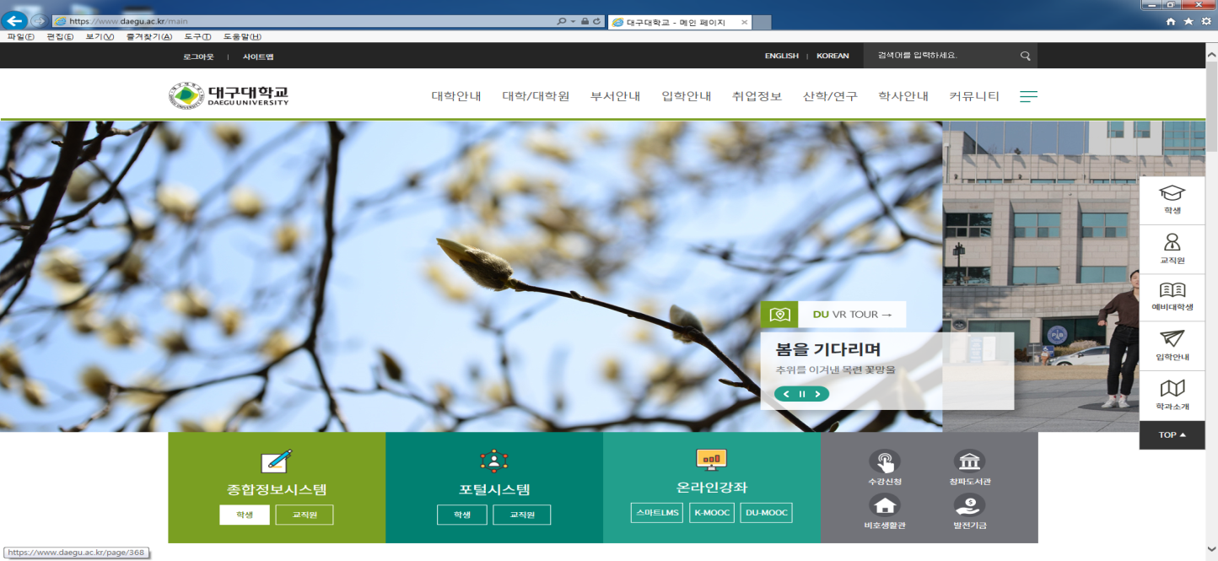
(Figure 1) Daegu University Homepage (www.daegu.ac.kr) → Click on "종합정보시스템/학생 (Comprehensive Information System/Student)" (top left-hand corner)

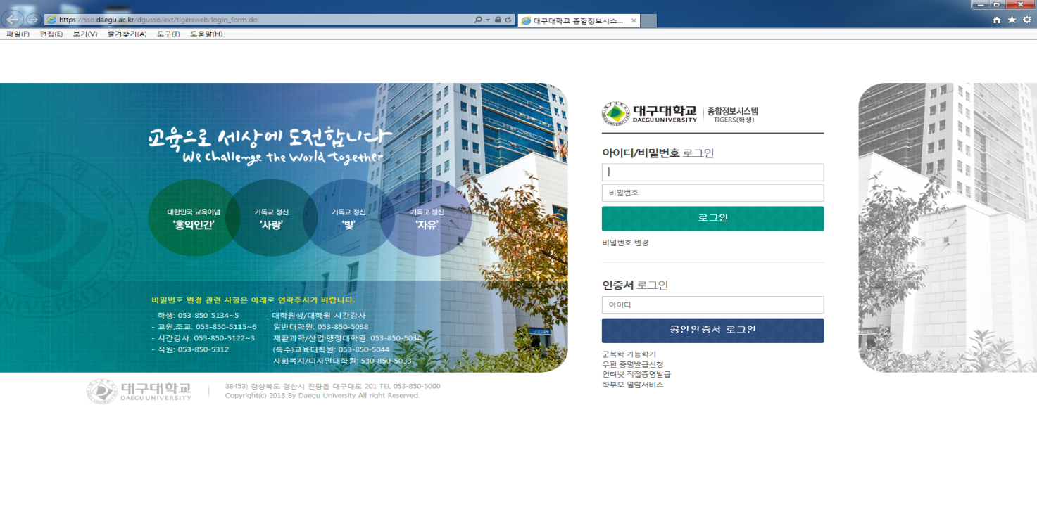
(Figure 2) Click "password 변경 (Password Change)"
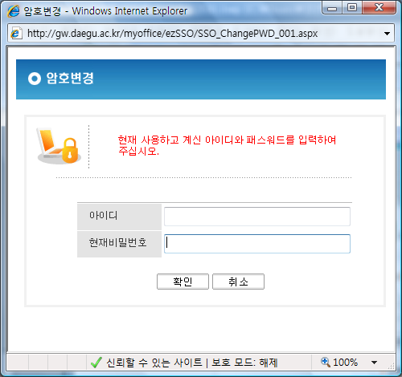
(Figure 2-1) Input "아이디 (Student ID number)" → Input "현재 비밀번호 (Input current password that is final 7 digits of your Alien registration number)" → Click "확인 (Confirm)” → Click "새비밀번호 (Input your new password)" → Click "새비밀번호 확인 (Reenter your new password)" → Click "확인 (Confirm)"

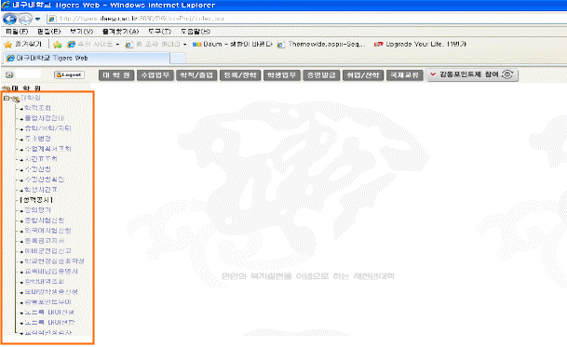
(Figure 3) Click on "대학원 (Graduate school)" (first gray button) → Click "시간표조회 (Timetable inquiry)" that is on the left submenus.

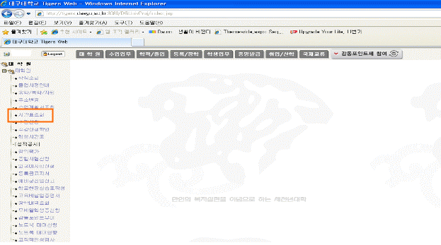
(Figure 4) After reviewing the timetable, register for lectures by either dragging the relevant lecture to your timetable or inputting the lecture number directly.

4. Supplementary Units (보충과목) Registration Procedure
▣ for Master Degree Program Students
Incoming master degree students who have different undergraduate majors from current majors must enroll and complete Supplementary Units (보충과목) from available undergraduate units.
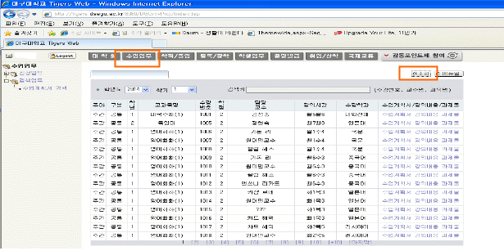
(Figure 1) Access to "종합정보시스템 (Comprehensive Information System)" → Click on "수업업무 (Classes)" (top) → Click on "검색업무 (Search)" (Left sub-menu) → Click on "조회 (Inquiry)" (Right top corner) → Locate the lecture numbers of the units you need to take → Return to the Graduate School lecture registration window and input the appropriate lecture numbers (Supplementary Units (보충과목) must be entered directly by lecture numbers)
▣ for Doctoral Degree Program Students
Incoming doctoral program students whose master's degree majors are different from current majors must enroll and complete Supplementary Units (보충과목) from available graduate units. Designated Graduate School Supplementary Units (보충과목) for each major are marked with an asterisk (*). Please be informed that when master's degree program students take lectures marked with an asterisk (*), the lectures will be considered as Required Unit (공통과목) or Major Unit (전공과목).

5. Registration Confirmation and Add & Drop Period: March 6(Wed) ~ March 8(Fri), 2019
♣ Methods and procedures are the same as regular lecture registrations.

6. Students are expected to attend lectures at the time and place described in the timetable.
Building locations can be checked via Daegu University's homepage → Click on "대학안내 (University Guide)" → "캠퍼스 지도 (Campus Map)"

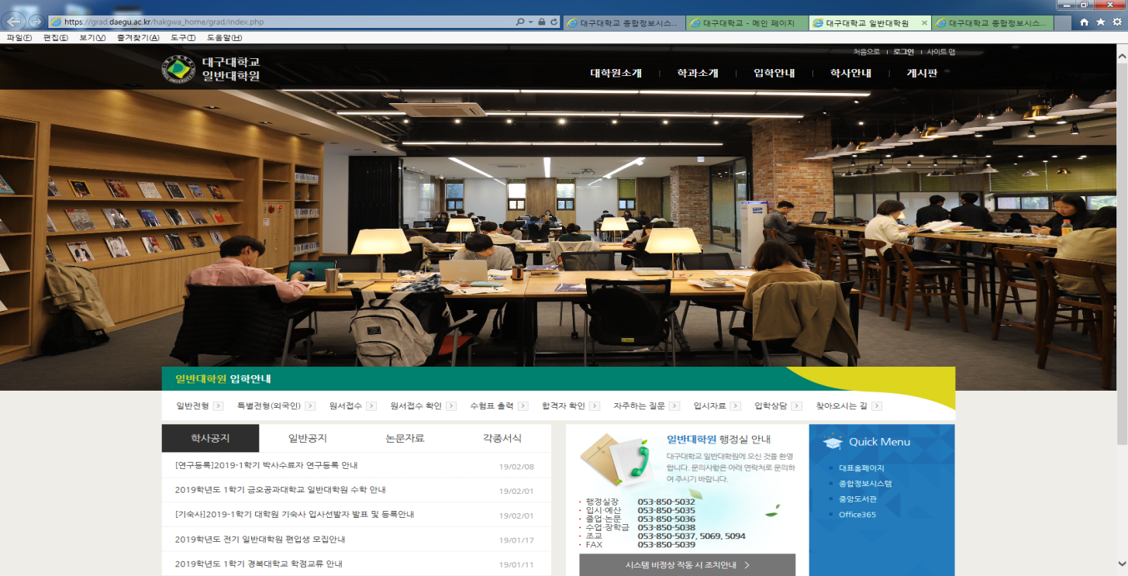
Graduate School Web Site
http://grad.daegu.ac.kr/

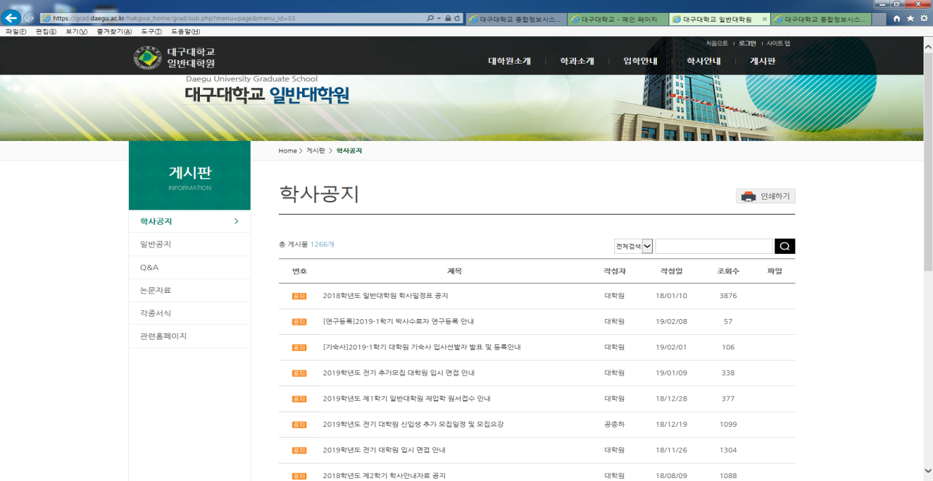
▣ How to connect ▣
▷ Click on "대학∙대학원∙기관" on Daegu University's main homepage (top) → Click on "대학원" → Click on "일반대학원” (http://grad.daegu.ac.kr/)
▷“게시판 (Board)" → “각종서식 (forms)": Here you will find the various forms and documents required by the Graduate School including Thesis Forms, Requesting or Returning from Leave, Transfer Credit Application for Supplementary Unit (보충과목) Credits form and so on.
▷ For more information such as Graduate School academic rules and regulations, and thesis guidelines, please check the Graduate School homepage.

▣ All announcements related to academic information at the Graduate School will be posted on the Graduate School homepage. Please visit the homepage on a regular basis in order to keep up-to-date with all the latest information.

Graduate School Academic Information

▣ Personal academic affairs management
Students at Daegu University's Graduate School are responsible for managing their own academic affairs. If necessary, they should seek advice from the relevant departmental chair and/or thesis supervising professors. In addition, students are expected to monitor all matters related to the following: lecture registration, credits, and personal information changes (i.e. address, phone number, etc.). If students have any problems, students must consult with the Graduate School's administration office immediately.

1. Credits Management
Students are expected to manage their required credits per program themselves according to Graduate
School academic rules and regulations related to academic affairs.

2. The maximum credits to take per semester
Degree | Research Works Unit  (Thesis supervision) (개별연구지도) | Major Unit (전공) | Supplementary Unit (보충과목) | Research Ethics  (연구윤리)
Master | 1 credit  (registration available beginning in the second semester) | 9 credits | 6 credits | 1 credit
Doctoral | 2 credits  (registration available in the second semester) | 9 credits | 6 credits | 1 credit
♣ Students cannot enroll in more than 9 credits per semester, however it is possible for them to enroll for 11credits for master's courses and 12 credits for doctoral courses during the semester when they sign up for the Research Works Unit (개별연구지도), the Research Ethics(연구윤리).

3. Required credits per degree
Master degree programs require at least 24 credits except for the Research Works Unit (개별연구지도) and the Research Ethics(연구윤리) while doctoral degree programs require at least 36 credits except for the Research Works Unit (개별연구지도), and the Research Ethics(연구윤리). To receive credit, a score of at least 70 points (letter grade C) is required in each unit of study and to complete coursework, a score of at least 80 points (letter grade B) is required.
Degree | Research Works Unit (Thesis supervision) (개별연구지도) +  Research Ethics(연구윤리) | Minimum credits for coursework completion | Supplementary Units
Master | PASS | 24 credits | 6 credits
Doctoral | PASS | 36 credits | 12 credits
♣ Students must complete the Research Works Unit (개별연구지도), the Research Ethics(연구윤리) and Required Units (전공과목).
♣ Students whose undergraduate or master's majors are different from current majors must take additional 6 credits for master's degree program and 12 credits for doctoral degree program.
♣ Elective Units (선택과목) refer to units that can be taken by students from other similar majors. Please refer to the Graduate School Office or each department office for more information.
♣ When students do not pass the Research Works Unit (개별연구지도), and the Research Ethics(연구윤리), they cannot complete their coursework even if they completed four semesters of study that is the term of full enrollment (The Research Works Unit (개별연구지도) and the Research Ethics(연구윤리) will be marked on a pass or fail basis).
♣ Students must register per credit if they do not complete the course due to inadequate credits for graduation or failure of Research Works Unit (개별연구지도) and the Research Ethics(연구윤리) up to 4 semesters.
[Payment Regulations]
Article 3 (Registration per credit) Tuition fees for students who surpass the Term of full enrollment (four semesters) will be charged as follows according to the credits they are enrolling in. Disabled students who are recognized by the President of Daegu University, however, can register per credit that they are enrolling in (except for the credits related to social volunteering).
2. Master's and Doctoral degree program
A. 1 credit to 3 credits: 50% of tuition
B. More than 4 credits: Full tuition

4. Term of full enrollment
Students must be fully enrolled for two academic years (four semesters).

5. Term of coursework
- Master degree program: 3 years
- Doctoral degree program: 5 years
♣ Students must complete their coursework within the above-mentioned periods.

6. Grading System
Letter Grade | Scores | Grade Point Average (GPA)
A | 90 ~ 100 | 4.0
B | 80 ~ 89 | 3.0
C | 70 ~ 79 | 2.0
F | 69 and below | 0
♣ Credit will not be granted if students are absent for one-third of coursework in a semester without appropriate reasons.

7. Completion of Supplementary Units (보충과목)
A. Students must check if they should complete Supplementary Units (보충과목) using the "학적조회 (Academic record reference)" in the "종합정보시스템 (Comprehensive information system)."
(1) If incoming master degree students are from different undergraduate majors from their current majors, they must obtain at least 6 undergraduate credits as designated by the Graduate School Office.
(2) If incoming doctoral students are from different master degree majors or from the Special Graduate School or Professional Graduate School with related majors, they must obtain at least 12 credits from designated Supplementary Units (lectures marked with an asterisk) in their department curriculums.
* the terms "Special Graduate School" and "Professional Graduate School" refer to those graduate schools falling outside the scope of each university's regular graduate school.
B. Recognition of Supplementary Unit (보충과목) credits
If you have completed units from your previous education that are similar to the Graduate School's Supplementary Units (보충과목), you can submit a "Transfer Credit Application for Supplementary Unit (보충과목) Credits" form. In this case, a maximum of 6 credits for master degree programs and 12 credits for doctoral degree programs can be transferred.
♣ Submission period of "Transfer Credit Application for Supplementary Unit (보충과목) Credits" form: from March 4 (Mon) to March 9 (Fri), 2019
♣ Submit to: Graduate School Office (11th Floor, Seongsan Hall)
C. Completion time
(1) Master programs: Except for recognized transfer credits, students must acquire all required undergraduate unit credits before the completion of the degree program.
(2) Doctoral programs: Except for recognized transfer credits, students must acquire all required designated Supplementary Unit (보충과목) credits from the available designated supplementary units for Doctoral Degree Program students before the completion of the degree program.
✐ Designated Graduate School Supplementary Units (보충과목) are marked with an asterisk (*).
✐ Doctoral Degree Program students must obtain at least 12 credits of supplementary units
D. Maximum credits to take: Credits for enrollment in each semester cannot exceed 6.
E. Credit recognition: Credits for Supplementary Units (보충과목) are not included when calculating students' GPA (grade point average).
F. Other
(1) Students must complete all applicable Supplementary Units (보충과목) prior to graduation.
(2) If incoming students have submitted a "Transfer Credit Application for Supplementary Unit (보충과목) Credits" form, they should check the status of their application online. Visit the Daegu University website and click "종합정보시스템 (Comprehensive Information System)" → "대학원 (Graduate School)" → "성적조회 (Results Inquiry)".

8. Information for taking or returning from a leave of absence
A. Application submission period: Refer to the annual academic calendar
B. The duration of a single leave cannot exceed 2 semesters and total leave cannot exceed 4 semesters.
C. When the leave period is finished, students must submit an application to return from leave during the designated period in each semester.
D. Students who are willing to extend their leave without returning must submit an "휴학연기원서 (Application for Leave Extension Form)" and get approval from the Graduate School dean.
E. Students who are willing to take a leave for pregnancy, birth delivery, and nurturing need to submit an “육아휴학 (leave for nurturing) and should submit relevant document (duration : within 1 year, the period not included in the general leave of absence)
F. Applications can be made through "종합정보시스템 (Comprehensive Information System)" → "대학원 (Graduate School)" → "휴학/복학/자퇴 (leave of absence/return from leave/drop out of school)".

9. Registration of changes to personal information and contact information
If there have been changes related to your personal and contact information such as residential address, occupation, phone numbers, etc, you should change them on the "종합정보시스템 (Comprehensive Information System).
※ Keeping your contact information up-to-date is essential for doctoral degree program students. Doctoral students are required to register for research study after completion of their coursework. In order to receive a tuition bill for research study, students must ensure that their contact information is up-to-date. Research study is charged at about 10% of regular tuition and must be completed at least once and to a maximum of four times.

10. Registration for research study of Doctorate degree students
A. Eligibility : Doctorate degree students who completed required semesters and credits for graduation.
B. Registration procedure : applicants need to register during the designated registration period after submitting the application for research study registration.
C. Registration fee : one tenth of the registration fee of the forth semester for Doctorate degree
D. Benefits for registered students : registered students can
-proceed to the relevant steps for the Doctorate degree thesis submission
-use the library and borrow books, and laboratories
-join in the seminars or workshops for graduate school students
-request their Student ID card when lost
E. Unregistered students cannot process the relevant steps for thesis submission and so they need to complete the research study registration in case they want to present their thesis in the semester.

11. Language Requirements for the graduation of international students
- International students should qualify one of the following requirements before graduation.
A. To pass TOPIK(한국어능력시험) Grade 4 or above(Grade 3 for the division of Art and Physical
Education)
B. To take the Korean Language Course designated by the graduate school and provided by the Office
of International Affairs
C. When there are such unavoidable reasons granted by Daegu University President

12. Other
A. Timetables will not be distributed individually and can only be checked at the Graduate School homepage.
B. To enroll in Supplementary Units (보충과목), students must submit a "Recognition of Supplementary Unit (보충과목) Credits" form. Approved transfer credits will be deducted from total credits required.
✐ For example, if 3 credits are approved and recognized as supplementary transfer credits in a master degree program students then just 3 credits remain to be completed.
C. For more detailed information about thesis writing, please refer to Graduate School thesis regulations as well as the general thesis writing guidelines at the Graduate School homepage.

Student ID Cards

1. Application period: Beginning : March 5 (Wed), 2019

2. Application method: After completing the "Student ID Card Application" form (check student ID number at the "종합정보시스템 (Comprehensive Information System)"), students must submit their application to the Daegu Bank branch located on the 1st floor of Seongsan Hall.

3. Required materials: "Student ID Card Application" form, 1 photo (3×4cm), student's Daegu Bank account number

4. Processing period
○ Beginning of the semester: Minimum 4 weeks
○ Middle of the semester: approximately 2 weeks
(The Graduate School Office will send text message to students' mobile phones to those whose student card is ready to pick-up.)

5. Application procedure
▣ Daegu Bank account holders
Complete and submit the "Student ID Card Application" form to the Daegu Bank branch located on the 1st floor of the Main Administration Building, Gyeongsan Campus → Confirmation of issuance through mobile phone text message → Pick up your student ID card at the Graduate School Office
▣ Non Daegu Bank account holders
You must have a Daegu Bank account to receive your student card. If you do not have a Daegu Bank account, you can open one at the Daegu Bank branch located on the 1st floor of the Main Administration Building (You should bring your ID). → Complete and submit the "Student ID Card Application" form to the Daegu Bank branch → Confirmation of issuance through mobile phone text message → Pick up your student card at the Graduate School Office.
✐ In the event that you lose your student card, you must report the loss to Daegu Bank.
✐ When reissuing your student card and changing the picture on your card, please write "사진변경 (replacement of picture)" in red ink on the right side of the picture.

6. Lending books during the student ID card processing period
○ Required documents for borrowing
- Identification card (Alien Registration Card or Passport)
- Student ID Number

Guidelines for Dissertation Thesis Submission

1. Nomination of thesis supervising professor
A. Thesis supervising professors must be selected within 6 months from admission to graduate school (prior to the end of their first semester).
B. The change of thesis supervising professor is impossible. Ensure that you make your selection carefully and with discretion.

2. Foreign language examination and Comprehensive examination
In order to have a thesis considered for master or doctoral degrees, students must pass both the foreign language examination and comprehensive examination. For more information pertaining to these exams, please refer to the Graduate School academic regulations as well as the general thesis writing guidelines at the Graduate School homepage.

A. Foreign language examination
○ Eligibility: Students who completed at least one semester of study
○ Tested Language: English. For international students from English speaking countries the foreign language examination will test Korean proficiency and for international students from non-English speaking countries the foreign language examination will test either English or Korean proficiency.
○ Students with exceptional TOEIC, TEPS, TOEFL, IELTS, or TOPIK scores who fall into one of the following categories are exempt from taking the foreign language exam (The scores should be earned within two years from the beginning of the semester).
Department | TOEIC | TEPS | TOEFL |  |  | IELTS | TOPIK
Department | TOEIC | TEPS | PBT | CBT | IBT | IELTS | TOPIK
Humanity and Social Science | 750 | 625 | 550 | 210 | 77 | 6.0 | 5
Natural Science | 700 | 583 | 513 | 195 | 71 | 5.5 | 5
Engineering | 650 | 541 | 476 | 181 | 66 | 5.5 | 5
Arts & Design and Health Science | 550 | 430 | 403 | 150 | 52 | 5.0 | 5
* TOPIK (Test of Proficiency in Korean) is applicable to international students except for overseas Korean residents and Korean-Chinese.

B. Comprehensive examination
(1) Eligibility
○ Master degree program: Students who have completed at least two thirds of credits (a minimum of 16 credits) required for graduation with a GPA of 3.0 (grade B) and higher
○ Doctoral degree program: Students who have completed at least two thirds of credits (a minimum of 24 credits) required for graduation with a GPA of 3.0 (grade B) and higher
(2) Tested subjects
○ Master degree program: Students select 2 types of Major Units (전공과목) from the courses that they have already taken. Students can apply for up to 1 units from the same professor.
○ Doctoral degree program: Students select 3 types of Major Units (전공과목) from the courses that they have already taken. Students can apply for up to 2 units from the same professor.

3. Eligibility of submitting degree requesting thesis
For more information please refer to the Graduate School homepage ("주요학사안내 (Main Academic Information)."
A. Master degree program: Students who have been fully enrolled for at least four semesters and who have completed at least 24 credits
B. Doctoral degree program
- Students who have been fully enrolled for at least four semesters and who have completed at least 36 credits
- Students who completed their coursework and registered for research study
C. Students who have an academic average of at least grade B (3.0 GPA)
D. Students who have passed both the foreign language examination and the comprehensive examination
E. Students who have undergone supervision by their thesis supervising professor for a minimum of one semester
F. Students who have passed their thesis proposal presentation and screening
G. Students who have passed their thesis draft presentation and screening
H. Students who have passed their degree requesting thesis presentation and screening

※ Students must successfully complete the thesis screening procedure in order to obtain master or doctoral degrees. As such, students must be well aware of the rules and regulations related to theses. These rules and regulations are posted on the Graduate School homepage under 학칙·규정·논문작성지침 (Academic rules·regulations·Thesis writing guidelines).

Dissertation Thesis Examination

Thesis proposal Examination  (논문계획서심사) |  | Proposal of dissertation thesis presentation  (논문계획서 발표) | ● Master's Degree Program: from the 3rd semester of study  ● Bachelor & Master's Accelerated Degree Program: from the 2nd semester of study  ● Doctoral Degree Program: from the 3rd semester of study
 |  | ↓
Submission of the report of
thesis proposal
(논문계획서 심사결과보고서 제출)
 |  | ↓
 |  | Submission of the recommendation for thesis examiners (심사위원 추천)/  Submission of the application for thesis presentation and examination  (논문발표 및 심사신청서 제출) | ● Students must submit their application for  thesis screening and pay the screening fee when thesis examiners are appointed.
 |  | ↓
 |  | Public oral presentation of thesis (공개발표) | ● Public presentation of degree requesting thesis
 |  | ↓
Dissertation Thesis Examination  (학위논문심사) |  | Submission of the results of public  oral presentation of thesis  (공개발표 결과보고서 제출)
 |  | ↓
Thesis examination (논문심사) /
(First defense / Second defense / Final defense)
 |  | ↓
Submission of the final report of dissertation examination
(논문심사결과보고서 제출)
 |  | ↓
Application for degree requesting thesis submission (학위청구논문제출신청서)/
Submission of thesis hard copy
(완성논문 제출)
Graduate School Scholarships

1. Daegu University Scholarships (*The scholarships can be changed according to the University Budget )

A. International graduate research assistantship
1) Application: The Office of Research of Daegu University notifies all the professors of the announcement in June and December.
2) Students who are awarded assistantship by the Guideline for International Research Assistantship of the Office of Research receive a waiver of tuition and fees.
B. Scholarship for international students
* This scholarship is applied to the students who are admitted to Daegu University from the 2019 Spring Semester.
1) At the First Semester of study
* Eligibility and amount of tuition reduction
- Students who qualify one of the following requirements receive a tuition reduction accordingly.
- Students whose mother language is English, only TOPIK and DU TOPIK scores are applicable.
- This tuition reduction does not apply to the Korean Government Scholarship students and International graduate research assistants.
* If students are eligible for more than two classifications of tuition reduction, they should choose one of them.
Classi-fication | TOEIC | TOEFL |  | TEPS | IELTS | KOREAN |  |  | Amount of  Tuition Reduction
Classi-fication | TOEIC | CBT | IBT | TEPS | IELTS | TOPIK  (한국어  능력시험) | DU  TOPIK | Students who are recommended on the basis of their Korean language proficiency  (한국어능력우수추천) | Amount of  Tuition Reduction
A | 800 and above | 287 and above | 118 and above | 689 and above | 6.0 and above | Level 5 | - | - | 60% of tuition
B | 700 and above | 195 and above | 71 and above | 583 and above | 5.5 and above | Level 4 | - | - | 50% of tuition
C | 650 and above | 181 and above | 66 and above | 541 and above | 5.5 and above | Level 3 | Students who pass the DU TOPIK. | Students who are recommended. | 40% of tuition
2) From the Second Semester to the Fourth semester of study
* Eligibility and amount of tuition reduction
- Students whose GPA of the previous semester are at least 70 points are eligible for the above-stated tuition reduction.
* If students are eligible for more than two classifications of tuition reduction, they should choose one of them.

C. Research Achievement Scholarship
1) Eligibility
a) Students who are enrolled in Master or Doctoral program and publish articles in their major field of study within 2 years of study; Students who are enrolled as part-time or completed their coursework are excluded.
b) Students who are enrolled in Master or Doctoral program majoring in Art and Physical Education and who are awarded in international/domestic competitions in their major field of study within 2 years of study; Students who are enrolled as part-time or completed their coursework are excluded.
2) Research Achievement Grade and Scholarship amount
a) Grade A: Publishing articles in SCI, SSCI or A&HCI Journals/ less than 1,200,000 Korean Won (KRW)
b) Grade B: Publishing articles in SCIE or SCOPUS journals or academic journals accredited by the Korea Student Aid Foundation (KOSAF)/ less than 500,000 KRW
c) Grade C: Publishing articles in academic journals in the process of accrediting assessment by KOSAF, awarded in accredited international competitions, or awarded Special Selection Awards in the Korea National Art Competition or Korea Industrial Design Competition/ less than 400,000 KRW or less
d) Grade D: Publishing articles in international general academic journals or journals presented by academic associations registered in KOSAF or the Korean Association of Academic Societies, or awarded a prize in nation-wide competitions/ less than 250,000 KRW or less
e) Grade E: Listing articles in proceedings of international academic conferences of which researchers' nationalities are more than two countries or in conference proceedings of the academic associations registered in KOSAF or the Korean Association of Academic Societies/ less than 200,000 KRW or less
3) Research Achievement Recognition
a) The research achievement published in journals until the end of semester is recognized. For those who are enrolled in their final semester and who submit certificate of anticipating article publication, the research achievement published before graduation is recognized.
b) When there are co-author(s) of articles or more than one participant of the competition award, the scholarship will be divided by the number of the participants (participants - one supervising professor).
c) For articles published in the international general academic journal, its editors' group and board of directors should be composed with people who come from more than three different countries. And articles should be published in foreign languages.
d) The research achievements which fall in the categories of Grade A, B, C, and D are recognized up to two times for each semester.
e) The research achievement which belongs to Grade E is recognized once for each semester in the case that the upper Grade A, B, C, and D are not recognized.
f) Scholarships should be provided within the budget of each fiscal year and the payment of Grade C, D, and E can be reduced when there are excessive applicants.
4) Disqualification
a) Research Achievements conducted through government grants or outside research contract of the supervising professor or co-researchers
b) Research Achievements on which students are not listed as Daegu University students
c) Exhibitions and presentations conducted in Daegu University
d) Research Achievements of which scholarship application is not submitted within two years of fully enrolled study
5) Required Documents
a) Application form for "학술연구실적장학금 신청서 (Academic Research Achievement Scholarship)"
b) A hardcopy of the article or a copy of article together with the cover and table of content of journal *Those who are enrolled in their final semester should submit certificate of anticipating article publication including the information on research participants' post and position.
c) Original copies of pamphlet and relevant evidencing materials such as recorded tapes, slides, photos, relevant documents, trophies, or medals.

D. Scholarship for Korean Language Program
1) Eligibility : International students who take and complete the Korean Language Program provided by the Office of International Affairs (Daegu University) and pass the minimum requirements (above 80 % attendance rate and 70 points in the final test)
2) Amount : 100 of the tuition for Korean Language Program
3) Others
-The scholarship will not be conferred for those who do not satisfy the above eligibility.
-The scholarship will be affordable one time only.

2. Sponsored scholarships
Hyeongae Scholarship Fund, Ssangyong gomduri, Korea Research Foundation, Songgok Scholarship Fund, Gyerim Scholarship Fund, Pyeongtong Scholarship Fund, Shoji Scholarship Fund

Access to Library

1. Telephone Directory
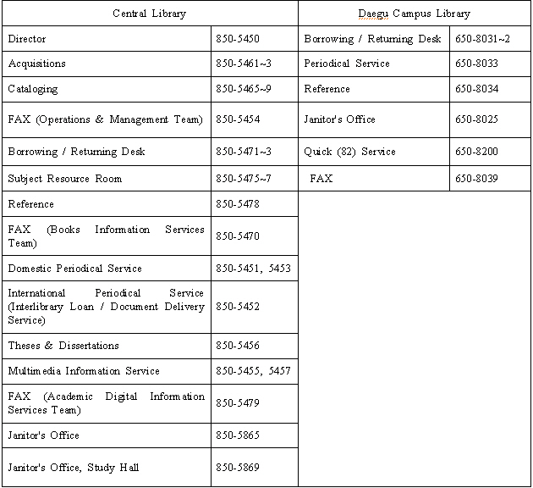

2. Opening Hours
Classification | Central Library |  | Daegu Campus Library
Classification | Weekdays | Saturdays | Weekdays | Saturdays
Archives | 09:00 ～ 22:00 | Closed | 09:00 ～ 22:00 | Closed
Reading rooms | 05:00 ～ 24:00 |  | 05:00 ～ 24:00
☞ Archives are open from 09:00 to 17:00 during Vacation Period.
☞ Days Library will be closed (limited to the archives).
■ National holidays ■ University Foundation Day (May 1)
■ Days to allow for the taking of general inventory (separate notice will be given)
■ Library opening hours may change if necessary.

3. Floor Information
Floor | Central Library | Study Hall | Daegu Campus Library
5 | - Western Languages Resource Room  - Private Library
4 | - Science, Technology and Arts Resource Room  - Science and Technology (Western Books) Resource Room |  | - Reading RoomⅢ
3 | - Humanities and Social Science Resource Room  - Literature and History Resource Room  - Browsing Room  - Private Library | - Study Room 6 and 7  - Outdoor Lounge | - Circulation Desk (Archive)  - Reading RoomⅡ  - Special Reading Room
2 | - Foreign Periodicals Room  - Dissertations Room  - References Room  - Copy Room | - Study Room 4 and 5  - Laptop Study Room  - Outdoor Lounge | - Reading RoomⅠ  - Periodicals Room  - References  - Copy Room
1 | - Director's Office  - Operations & Management Team (acquisitions/Cataloging)  - Books Information Services Team (Checkout/Return)  - Academic Digital Information Services Team (Domestic Periodicals Room)  - Digital Information Room  - Copy Room | - Study Room 2 and 3  - Study Room for Special Needs  - Lounge  - Janitor's Office  - Student-aids' Office | - Reading Room for Special Needs  - Newspaper Stand
Basement | - Archive (Independent Volume and Periodicals)  - Machine Operating Room | - Study Room 1  - Multimedia Room  - Group Study Room  - Cafeteria | - Archive (Independent Volume and Periodicals)

4. College Resource Rooms
Classification | College | Location
College  Resource  Rooms | College of Economics and Business Administration | First floor of the college building
College  Resource  Rooms | College of Law | First floor of the college building
College  Resource  Rooms | College of Public Administration | First floor of the college building
College  Resource  Rooms | College of Social Sciences | Second floor of the college building 1
College  Resource  Rooms | College of Natural Sciences | First floor of the college main building
College  Resource  Rooms | College of Life & Environmental Science | First floor of the college building
College  Resource  Rooms | College of Arts and Design | - Fourth floor of the college building 2  - Third floor of the college building 5
Other | Biho Dormitory | First floor of the building

5. Check-out / Return
A. Check-out privileges and limits
Classification | Undergra-duate Students | Graduate Students | Faculty | Staff | Part-time Instructor | Local Residents / Alumni | Remarks
No. of books  / Period | 5 books / 14 days | 15 books / 30 days | 50 books / 180 days | 20 books / 60 days | 15 books / 30 days | 3 books / 10 days | Renewal is permitted only one time.
* Renewing items: If the check-out items are not overdue and not reserved by another user, the due date will be extended for another loan period for 14 days for undergraduate students, 30 days for graduate students, and 180 days for faculty members from the date of renewal. The renewal is permitted only one time.

6. Reservation
When your desired book is already checked out, you can make a reservation by entering your personal and contact information into the Library homepage. The service lets you check-out the book when it is returned. You can reserve up to 3 items. Reserved books are held in circulation desk for 3 days and then your reservation will be automatically canceled.

7. Overdue Sanctions
If you have overdue material, the following penalty will be imposed.
- Currently enrolled students: Borrowing privileges are suspended during the same number of days as the books are overdue.
- Students on a leave of absence, completed their coursework, expelled from Daegu University and Alumni: All the certificates will not be issued.

8. Lost / Damaged Books
Lost or damaged books must be compensated with identical items. When the compensation can not be made with an identical item, the replacement charge will be levied to the borrowers in accordance with library policies.

9. Academic Information Services
A. Interlibrary Loan / Document Delivery Service
(1) Interlibrary Loan / Document Delivery Service provide copying service for the archives which are not possessed by Daegu University from other institutes or libraries.
(2) Domestic and International Periodicals, thesis and dissertations, Separate Volume (partial copies or borrowing) and all the materials library users need.
(3) How to use the service
(A) Access to the Central Library web site (http://lib.daegu.ac.kr/index.jsp) → Click on "도서관 서비스 (Library Service)" → Click on "상호대차/원문복사 (DDS/ILL)" → Click on "상호대차신청 (Interlibrary Loan Request)" or;
(B) Registration for membership of the KERIS, NDSL, KORSA → Web application or;
(4) Inquires: Central Library (☎ 053-850-5463), Daegu Campus Library (☎ 053-650-8033)
(5) Fee and delivery period
- Fee can vary based on the institutes' policy which provides service.
- Delivery period includes the processing and delivery time of the institutes which possess the archive.
B. E-mail Service for International Academic Archive List and Original Copies
You can receive the most recent content of table of the international academic journals and original copies necessary for your academic research through your e-mail. Register in NDSL (http://www.ndsl.or.kr) and ask the service for interested academic journals. Then the content of table for the most recent issues and original copies (Daegu University's' subscriptions) will be delivered to you through your e-mail.

10. Useful Library Services
A. Book requests
Students can request books that are not in Daegu University's library through the library homepage (http://lib.daegu.ac.kr). Requested books will be purchased from book stores. The period from purchase order to bookshelf display will take approximately 20 days for domestic books and 40 days for international books (For further information, call extension 5462-3.)
Book Request | → | Duplicate copy check and Order | → | Purchase and Registration | → | Thematic Classification and Listing | → | Material Room Shelving
Library Homepage | → | Operations & Management Team | → | Operations & Management Team | → | Operations & Management Team | → | Books Information Services Team  (Various Materials Room)

B. e-Mail notification service upon book request process and result
Book request processes and results are notified to individuals by email for those who requested books through "Book Request" on the library homepage (http://lib.daegu.ac.kr).

C. Information for Open Library
By establishing an open library system which is shared with local citizens, the library can function as an information center for local citizens which encourages reading and provides knowledge and information. Furthermore, it can encourage local citizens, university alumni, and the disabled to actively utilize library materials.

D. Information for using other university libraries
Students who wish to view library materials in other universities (institutes) can obtain a request form called "외부기관 이용 의뢰서 (External Organization Usage Request)" offline or online.
- Offline request forms can be obtained in the Reference Material Room of Central Library or Reference Material Room of Daegu Branch Library.
- Online request forms are available under the menu of "이용자서비스 (User Service) / 외부기관이용 (External Organization Usage)" of library homepage (http://lib.daegu.ac.kr).

E. Central Library Blog Service
http://dulibrary.tistory.com/
Information about library news and reference materials
* For further information, visit the library homepage at http://lib.daegu.ac.kr/.

Additional Information

1. Issuance of Certificates
A. Gyeongsan Campus
- Academic Records Team (Location: Lobby floor, Seongsan Hall) ⇒ Korean/English certificates
- Automated Certificate Machine (Location: Lobby floor & 1st floor, Seongsan Hall) ⇒ Korean/English certificates
- Graduate School Office and College Administration Offices ⇒ Korean certificates
B. On-line
Access to Daegu University's homepage (www.daegu.ac.kr): Click on 학생서비스 (Student Services) → 증명발급 (Certificate Issuance) → 인터넷증명발급 (On-line certificate issuance)
✐ Students can request certificates from any College Administration Offices.

2. Health Services
Daegu University operates Campus Health Services in order to take care of the health of students, faculty and staff, and to cope promptly with medical emergencies on campus. Medical doctor is on standby for medical examinations and consultation.
A. Location and phone number: 2nd floor, Student Union Building 2 (☎ 053-850-4119)
B. Open hours: 09:00 - 17:00 (Monday through Friday)
C. Medical doctor's service hours
- During the semester: 09:30 - 17:00 (Monday through Friday)
- During vacations: 09:30 - 17:00 (Tuesday and Thursday / subject to change)
C .Health Services staff can take emergency measures and provide complimentary first-aid and medicines.

3. Daegu University Insurance for students
Accidents on/off-campus in connection with classwork may be covered by Daegu University Insurance. For more detailed information, please contact Student Affairs Team (☎ 053-850-5214).

A. The insured: Undergraduate and graduate Students enrolled in Daegu University
B. Maximum coverage
- Medical treatment: two million won per person per accident
C. Accidents covered by insurance
- Accidents on/off-campus in connection with classwork
- Accidents which happen on campus

4. Other campus facilities
A. Daegu Bank
- Location: 1st floor, Seongsan Hall
- ATM: You can find several ATMs on campus that are located on the 1st floor of the Seongsan Hall, Student Union Building 1 and 2, Ungji-gwan, Dormitory Administration Office Building, Main Gate, the Institute of Computer & Communication, and etc.
B. Post Office, Travel Agency, Book Store, Photocopy Center, Stationery Store (Art Supplies), Optical Store, Convenience store
- Location: 1st floor, Student Union Building 1, 2 and East community center

5. Others
A. Students are expected to keep abreast of important dates related to their respective programs.
B. For other inquiries please contact the Graduate School Office (Location: 11th floor, Seongsan Hall).
C. Websites
- Daegu University: http://www.daegu.ac.kr
- General Graduate School: http://grad.daegu.ac.kr

6. Departmental Directory
A. Overall administration of Graduate School Office : Mr. Jong-Hak Lee, General Manager (☎053-850-5032)
B. Registration/ Scholarships : Mr. Sunghawn Choie (☎ 053-850-5033)
C. Thesis / Foreign language and comprehensive examination / Dormitory / Budget : Mr. Jae Hong Jung (☎ 053-850-5036)
D. Admissions / Classes/ Foreign Student/ Certificates : Ms. Sun Yeo (☎ 053-850-5038)

Credit Transfer Application for Supplementary Unit Credits
(보충과목 학점 인정원)

Degree  Program | Master ( )  Doctoral ( ) | Department |  |  | Major |  |  |  | Student  ID #
Name |  | Phone #  Mobile Phone # |  |  |  | Admission  year |  | Academic Year:  - 1st Semester ( )  - 2nd Semester ( )
Previous  Education | Please write the information on your university from which transfer credit is requested (Name of University, Graduate School (if applicable), Department, and Major)
The above stated person has majored in a different department from the current major or has come from a Special Graduate School or Professional Graduate School. As such he/she is required to complete the supplementary units at this Graduate School.
Please approve this request for ‘credit transfer for the supplementary units’ on the credits that are achieved from the previous schools as follows.
Classification | Previously completed  units and credits |  | Requested Units and credits for recognition  as supplementary units |  | Approved  (Yes / No)
No. | Name of unit | Credits | Name of unit  -Master degree : choose from curriculum of the undergraduate programs  -Doctorate degree : choose from curriculum of the Graduate School with ‘*’ | Credits | Approved  (Yes / No)
1
2
3
4
5
7
8
Total
◆ For master degree programs up to 9 credits may be transferred while for doctoral degree programs up to 16 credits may be transferred.
◆ Required credits from the supplementary units for completion of coursework: 6 credits for Master degree programs and 12 credits for Doctoral degree programs

Attachment : 1. Official transcripts
2. 보충과목 학점인정 심사 의견서 (filled out by the department)

20 . . .

Applicant: (Signature)

Department Chair: (Signature)
To the Dean of Graduate School
Charge | Team  Manager |  | Dean
Daegu University Graduate School
보충과목 학점 인정원
과 정 |  | 학과 |  |  | 전공 |  |  | 학번
성 명 |  | 연 락 처  휴대폰번호 |  |  |  | 입학년도 | 학년도(전기․후기)
출신학교 | 대학(교) 대학원 학과 전공
위 학생은 비동일학과 또는 특수대학원 출신자로서 대학원에서 보충과목을 이수하여야 하는 바,
하위과정에서 취득한 학점을 아래와 같이 대학원 보충과목학점으로 인정받고자 하오니 승인하여 주시기 바랍니다.
구 분 | 기 이수과목 및 학점 |  | 보충과목으로 인정받고자 하는 과목 및 학점 |  | 인정  여부  (O/X)
구 분 | 이 수 목 명 | 학 점 | 인 정 과 목 명  - 석사과정생 : 학부 교육과정 참고  - 박사과정생 : 대학원 교육과정 참고  (*가 있는 교과목만 인정) | 학 점 | 인정  여부  (O/X)
1
2
3
4
5
6
7
계
◆ 입학원서에 기재된 최종학력 성적만 인정
◆ 석사과정은 9학점까지, 박사과정은 16학점까지 인정
◆ 수료에 필요한 보충과목 학점 : 석사 9학점, 박사 18학점

첨부 : 1. 성적증명서(입학지원시 제출한 증명서) 1부.
2. 학점인정 심사 의견서 1부.

년 월 일

신 청 인 : (인)

학 과 장 : (인)
대 학 원 장 귀 하
담 당 | 실 장 |  | 원 장

보충과목 학점인정 심사 의견서
소 속
학 번 |  |  | 성 명
▶ 반드시 교육과정 내용을 기재하여 주시기 바랍니다.
기 취 득 내 용 |  | 본 대학원 학점인정 내용
교과목명 및 교과목 내용 |  | 인정 교과목명 및 교과목 내용 |  |  | 인정 사유(학과의견)
교과목명 :  내 용 : |  | 교과목명 :  내 용 :
위와 같이 보충과목 학점인정 심사 의견서를 제출합니다.

년 월 일

신 청 인 : (인)

학 과 장 : (인)
대 학 원 장 귀 하

